**AIR QUALITY MONITORING**

**Problem overview :**

In today's rapidly urbanizing world, ensuring clean and breathable air has become a pressing concern. Rising pollution levels pose severe health risks to individuals, communities, and the environment. To combat this issue, there is a critical need for real-time, accurate, and accessible air quality data. Traditional monitoring systems are often limited in scope, accessibility, and real-time reporting capabilities.

Our problem lies in the lack of a comprehensive and efficient solution for continuous air quality monitoring. Current systems are either costly, stationary, or lack the ability to provide real-time data to the general public. To address this challenge, we aim to develop an innovative Air Quality Monitoring System based on the Internet of Things (IoT) technology. This system will provide real-time data collection, analysis, and dissemination, empowering individuals and communities to make informed decisions about their surroundings, health, and well-being.

By harnessing the potential of IoT, we aspire to create a robust, scalable, and user-friendly solution that not only monitors air quality parameters but also engages communities, policymakers, and environmentalists in the collective pursuit of cleaner air. Our objective is to bridge the gap between traditional monitoring methods and the digital age, facilitating a healthier, safer environment for everyone. Join us on this journey as we explore the world of IoT-driven Air Quality Monitoring and work towards a future where everyone can breathe clean, fresh air without compromise.

**Proposed Idea:**

In our rapidly urbanizing world, air quality monitoring is essential for public health and environmental sustainability. We propose an innovative solution leveraging the power of the Internet of Things (IoT) to create a robust and accessible Air Quality Monitoring System. Our idea focuses on providing real-time, accurate, and actionable air quality data to individuals, communities, and policymakers.

**Implementation of Our Idea:**

**1.IoT Sensor Nodes:**

Deploy low-cost, energy-efficient IoT sensor nodes equipped with various sensors (such as particulate matter sensors, gas sensors, temperature, and humidity sensors) to measure key air quality parameters. These nodes will be strategically placed across urban areas, industrial zones, and sensitive locations.

**2. Data Aggregation and Processing:**

Collect data from the sensor nodes and aggregate it in a central cloud-based platform. Implement algorithms for data cleansing and processing to ensure accurate and reliable information. Real-time data processing will allow for immediate response to changing air quality conditions.

**3. User-Friendly Interface:**

Develop a user-friendly web or mobile application where users can access real-time air quality information specific to their location. The interface will provide intuitive visualizations, historical data, and customizable alerts. Users can receive notifications when air quality levels reach predefined thresholds.

**4. Community Engagement:**

Encourage community participation by allowing users to report observations and issues related to air quality through the application. Implement social features such as forums and community-driven initiatives to raise awareness and promote collective efforts for cleaner air.

**5. Integration with Smart Devices:**

Integrate the air quality monitoring system with smart home devices. For instance, air purifiers can be automated based on real-time air quality data. This integration enhances the user experience and promotes healthier indoor environments.

**6. Data Analysis and Prediction:**

**Utilize machine learning algorithms to analyse historical data trends and predict future air quality conditions. Predictive analytics can aid authorities and individuals in making informed decisions to mitigate potential air quality issues.**

**7. Environmental Impact Assessment:**

**Provide tools for environmental impact assessment, allowing urban planners and policymakers to analyse the data and make data-driven decisions for sustainable urban development and environmental policies.**

**8. Public Awareness Campaigns:**

Organize awareness campaigns, workshops, and educational programs to inform the public about the importance of air quality and how they can contribute to improving it. Use the data collected to highlight the impact of individual and collective actions.By implementing this comprehensive IoT-based Air Quality Monitoring System, we aim to empower communities, enhance public health, and drive positive environmental changes. Together, let’s breathe life into the future with cleaner and healthier air for all.

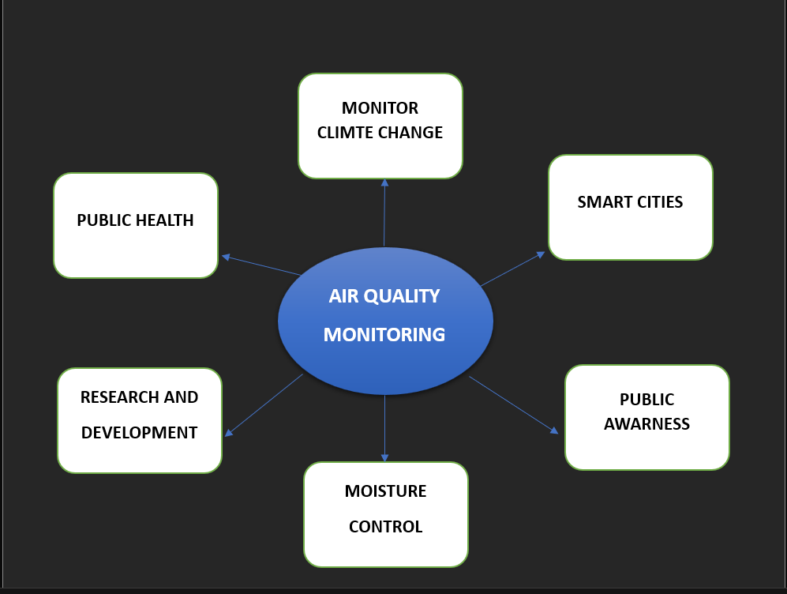

**Conclusion:**

In the pursuit of cleaner, healthier environments, the implementation of advanced Air Quality Monitoring Systems stands as a beacon of progress. Through our journey in exploring the depths of IoT-driven solutions, we have unearthed the transformative power of real-time data and community engagement. As we conclude our exploration of air quality monitoring, several key takeaways and future directions come to light. Real-time air quality data empowers individuals, communities, and policymakers to make informed decisions. Armed with accurate information, people can adjust their activities, policymakers can implement targeted policies, and communities can actively participate in creating healthier surroundings.